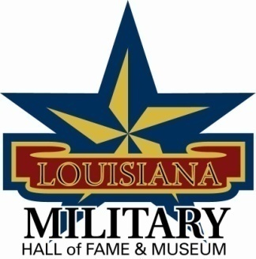
Louisiana Military Hall of Fame & Museum
Chris Crusta Memorial Airport
911 Revis Sirmon Loop
Abbeville, LA 70510
337-898-9645

Governing Board Meeting Minutes – Saturday, December 8, 2012
10:15 am inside the Military Hall of Fame & Museum

Meeting was called to order at 10:15 am followed by Prayer and Pledge of Allegiance.

Dewey Coles discussed nominations for the induction ceremony for 2013.

Gen LeBlanc talked about Bank letters for sponsorships for the Induction ceremony.

Johnny Raymond discussed possibly getting Jake Delhomme to do a service announcement and have it broadcasted on television for publicity of the museum.

Crystal Mouton discussed the sign and placement of the sign that has been donated by Quest Motorcycles.

Meeting Adjournment at 11:30 am.

